Last Name: _________________________
Date _____________________

Selinsgrove Area Recreation, Inc. 2019 Season Pool Pass Application
www.selinsgrovepool.org

FOR OFFICE USE
Pass Type Discount
___ Family $225 $200
___ Single $125 $100
___ Senior $60 $40
___ Babysitter $ 30

*Seniors are 60 years and older.
*The Babysitter pass must be added to a family pass and can only be used when babysitting in the absence of a parent.

Amount Paid: $_______________
Check # ______ Cash _______
Received by: __________________________
*Please make checks payable to SARI*
Date ___________________
Name ___________________________________

Address: _________________________________

_______________________________

Email ____________________________________

Phone: (H) _______________________________

(C)___________________________________

EMERGENCY INFORMATION:

Contact Person: __________________________

Phone Number: __________________________

One membership per application. Family memberships are for immediate family only.
*A family membership is recognized as those individuals living in the same household; however, it does not include grandparents, aunts, uncles, grandchildren, and children older than 18 years of age (except college students). Any exceptions will be at the discretion of the pool manager.

Please list all members to be included on the pass, as well as yourself.

Full Name Age Relationship Health Concerns/Allergies
- _______________________________________________________________________________________________
- _______________________________________________________________________________________________
- _______________________________________________________________________________________________
- _______________________________________________________________________________________________
- _______________________________________________________________________________________________
- _______________________________________________________________________________________________

Please review the pool rules on the following page and keep rules page for your reference.

I have read and understand these rules. I agree to abide by them and will review them with my children.

Applicant’s Signature: ___________________________________________________________
Please complete and return to SARI, P O Box 172, Selinsgrove, PA 17870
Email questions to selinsgrovepool@gmail.com or contact us on Facebook.

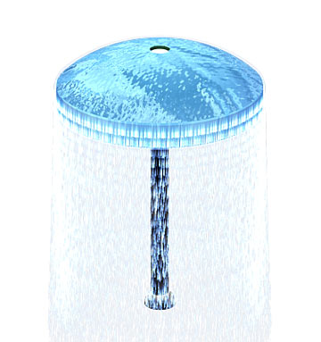

Selinsgrove Area Community Pool—Summer 2019
Please keep this page for your review.

Hours:
- Open daily from 12 pm to 7 pm.

Daily Admission Fee:
No daily admission fee for season pass holders.
- Free to children five and under
- $5.00 per person age 6-59
- $3.00 for seniors (age 60+)
- Half price after 5 pm

Pool Rules: See Reverse Side

Swim Lessons:
- Lesson fee is $20 per child per session
- Registration forms can be picked up at the pool office during pool hours
- July 9th-13th
- July 16th-20th
- July 23rd-27th

Food
- Concession Stand onsite.
- Snack and soda vending machines onsite.
- Patrons may bring personal food/drink/coolers. (No glass containers, please)

Pool Rental:
- Rent the pool for Birthday Parties, Office Parties, or special events. Call the Pool Office
(during pool hours) at 570-884-3500 for more information
- All pool rules apply for party rentals.

Pool Features:
- Zero-entry for handicapped accessibility
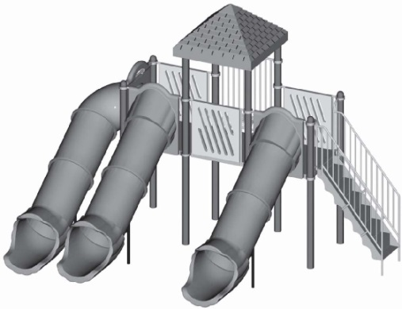
- Diving stand
- Enclosed tube slide
- T-cross bar
- Rain drop
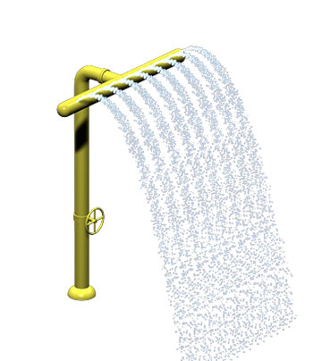
- Smoke-free environment

SELINSGROVE COMMUNITY POOL RULES

- Smoking is Prohibited on any part of the property, including the Parking Lot
- Proper Swimming Attire must be worn always, i.e. Swimming Suits, Trunks, Board Shorts, Swim Shirts, Cover-ups, etc. Street clothes including cutoff jeans, loose fitting tank tops and baggy T-shirts present a hazard and are not permissible in the pool.
- Acceptable Language must be used at all times. Swearing will not be tolerated.
- No Running in Pool Area.
- Alcoholic Beverages are prohibited on all Pool Property.
- All Glass containers are prohibited on pool property.
- Flotation Devices may not be worn on diving boards.
- Proper take-off only on diving boards. Users are not permitted multiple bounces and may only jump from a standing position. (No jump to seated bounces).
- Lap Lane is reserved for lap-swimming only.
- Do not approach Lifeguards while they are on duty. All questions should be directed to the Desk Clerk or Manager.
- Children 11 and under must be supervised by an individual 16 or over at all times.
- Children 6 and over are not permitted in the Baby Pool.
- Regular Diapers are not permitted in either the main pool or baby pool. Swim Diapers MUST be used.
- Patrons using the baby pool (including caregivers) must be in proper swimming attire.
- The shallow end of the pool is for children, non-swimmers and caregivers. Those unable to swim should remain in this section of the pool and should not go beyond the shallow area.
- Pool passes are to be used by pass-holder only, including baby-sitter passes. Violation of this rule will result in revocation of pool passes without refund.
- In the event of thunder or storms, all patrons will be asked to exit the pool for a period of 30 minutes. When thunder-free for 30 minutes, patrons will be allowed to re-enter the water. No refunds will be given in the case of inclement weather.
- In the event of rain without thunder, patrons will be allowed to swim until the bottom of the pool can no longer be seen by the lifeguards. At this point, all patrons will leave the water until the rain subsides to the lifeguard’s discretion.
- Caregivers are expected to review the pool rules that are posted throughout the pool area with their children.

Any violation of rules could result in disciplinary action in the form of a reminder (warning), benching, or removal from the pool grounds. Though these are our policies as listed, we reserve the right to add to this list as deemed appropriate. If patrons are behaving in a reckless or inappropriate manner we and the lifeguards reserve the right to restore the environment to a safe and enjoyable atmosphere. This includes, but is not limited to: persons being removed from the pool, revocation of pool passes without refund and permanent banning and exclusion.

